Module 02 Lab 01 Data Wrangling Used Car Pricing Screenshot Evidence and Discussion
Reference label for this notebook: Lab1 (each heading below is numbered Lab1_1, Lab1_2 and so on).
This document collects the screenshots of Module 02 Lab 01, data wrangling on the used car dataset, and gives each one a heading that follows the notebook from the first section to the last. The lab loads auto.csv, 205 rows and 26 columns with no header row, then identifies the missing values, corrects the data types, converts units, normalises columns, bins a continuous attribute and builds indicator variables. The screenshots are numbered in the order they appear in the notebook and each image is captioned with its file name.

Lab1_1. Section 1 Import data and the source of the automobile dataset
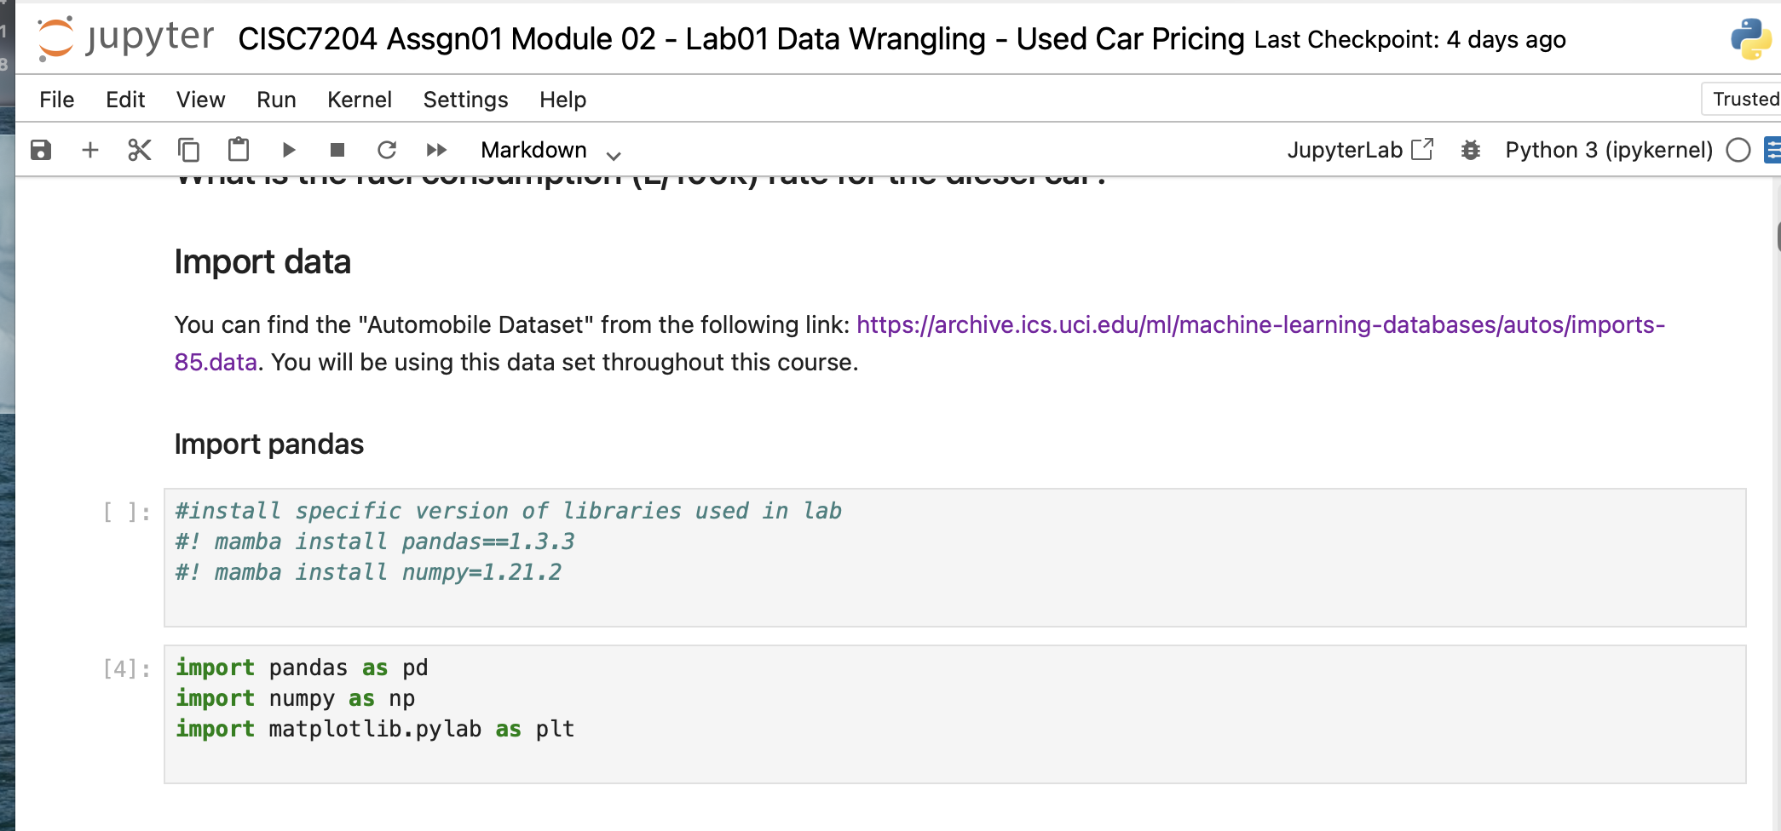
Screenshot file: 01_markdown_Data_Wrangling.png
The section opens the data wrangling lab and names the data source, the UCI automobile dataset that is delivered as auto.csv. It sets out what the rest of the notebook does: find the missing values, fix the data types, rescale ranges, bin continuous attributes and create indicator variables.

Lab1_2. Section 1 Reading the dataset into a dataframe
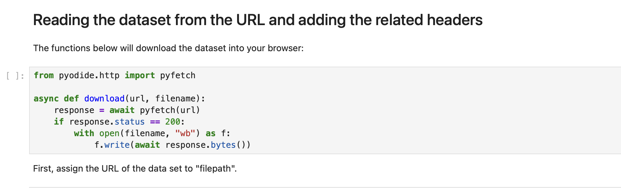
Screenshot file: 02_markdown_Reading_the_dataset.png
The download helper for the lab is shown here. It fetches the CSV into the working folder so the dataframe can be built from the local copy instead of a live URL.

Lab1_3. Section 1 Downloading the dataset file
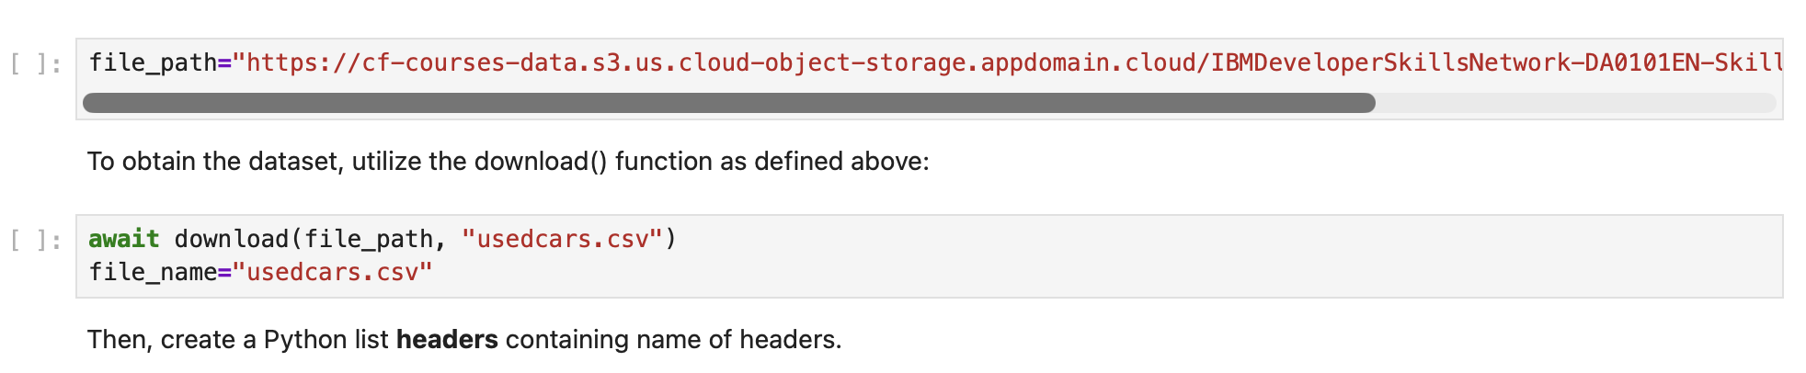
Screenshot file: 03_markdown_Download_dataset.png
The call that runs the helper and stores the file is shown, with the note that the same steps would be skipped when the notebook runs on a local machine with the file already present.

Lab1_4. Section 1 Loading the data with the documented column names
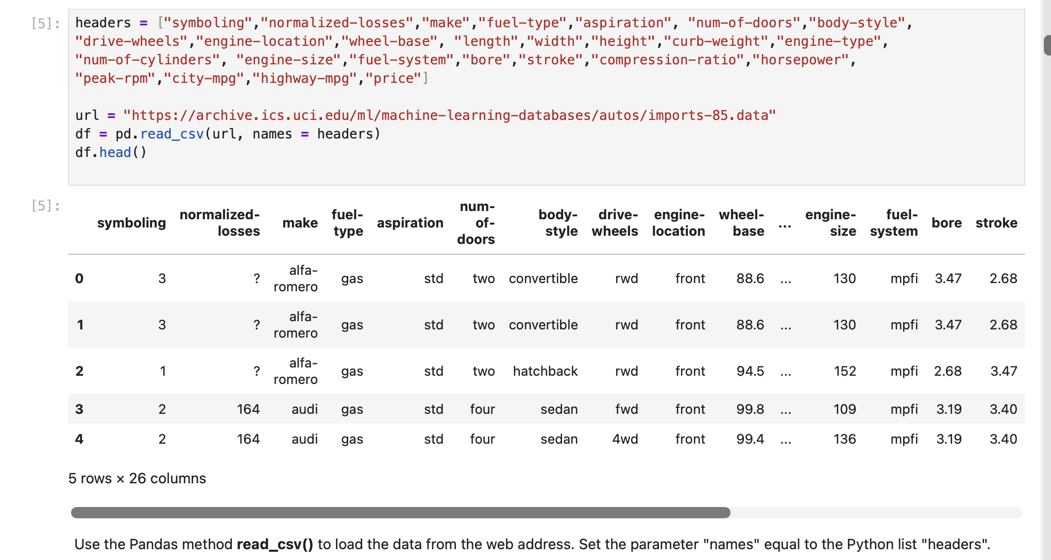
Screenshot file: 04_markdown_Load_data_with_headers.png
The headers list with the 26 attribute names is defined and assigned to the dataframe, so every later cell can address the columns by name.

Lab1_5. Section 1 Reading the CSV straight from its URL
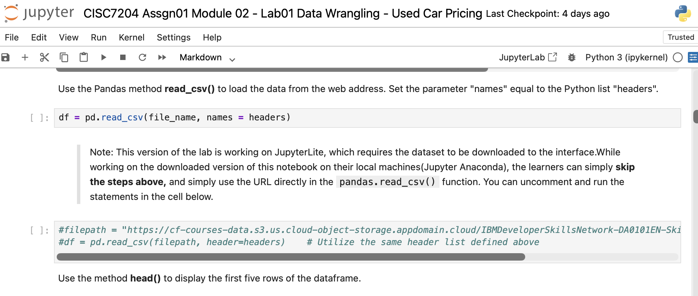
Screenshot file: 05_markdown_Read_csv_with_headers.png
The alternative route reads auto.csv from the course URL. It is kept as the local machine option, while the notebook itself uses the downloaded copy.

Lab1_6. Section 2 Introduction to missing data
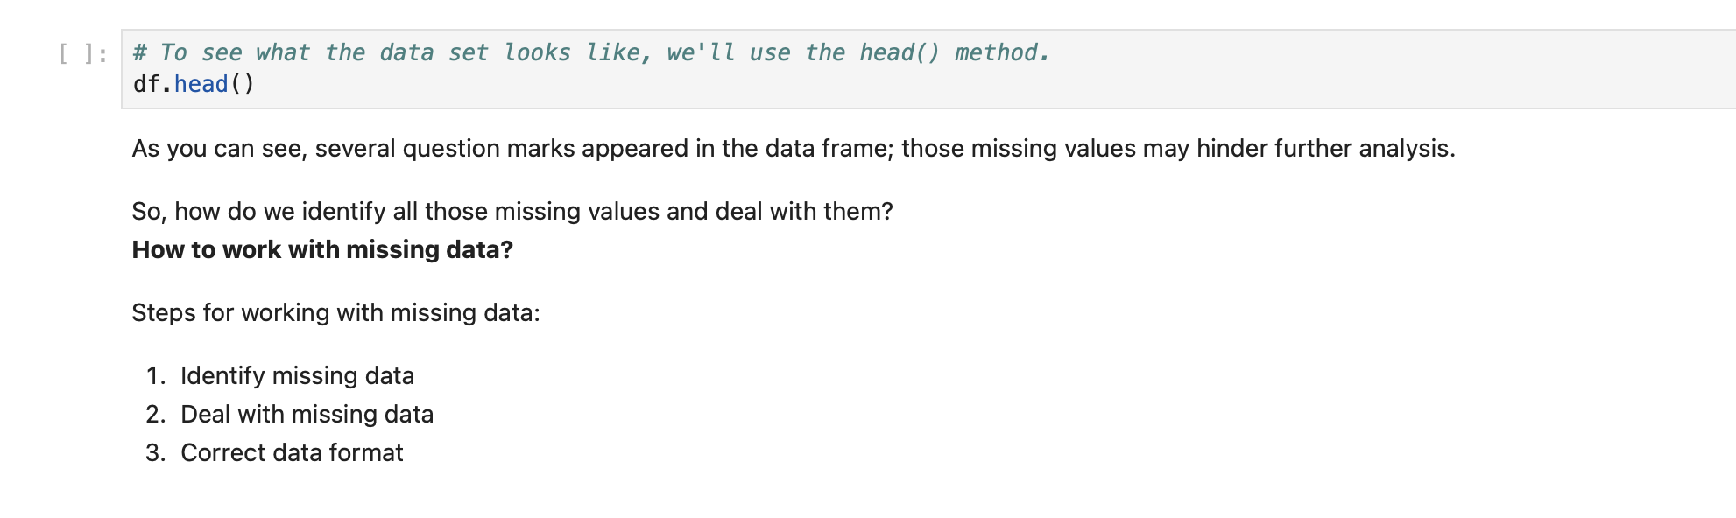
Screenshot file: 06_markdown_Missing_data_intro.png
The frame is inspected and the question marks that stand for missing entries are pointed out, with the steps that will be followed to handle them.

Lab1_7. Section 2 Converting the question marks to NaN
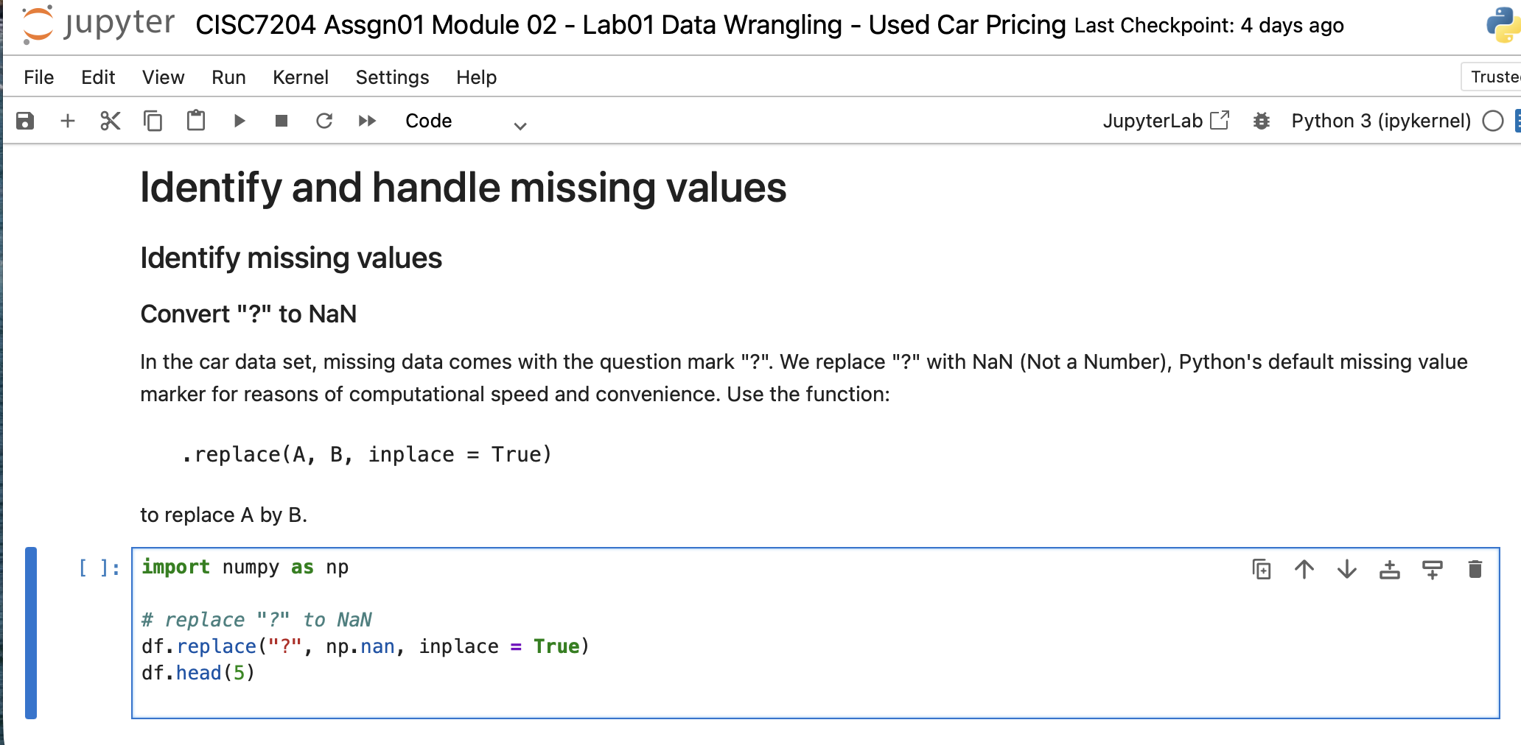
Screenshot file: 07_markdown_Convert_question_to_NaN.png
Using replace, the question mark marker is turned into pandas' standard missing value so that it can be counted, displayed and filled by the normal pandas functions.

Lab1_8. Section 2 Evaluating missing data with isnull()
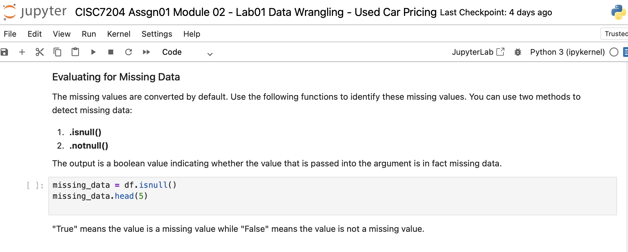
Screenshot file: 08_markdown_Evaluating_missing_data_isnull.png
isnull() is introduced as the way to obtain a boolean mask that marks every missing entry of the dataframe.

Lab1_9. Section 2 Counting the missing values in every column
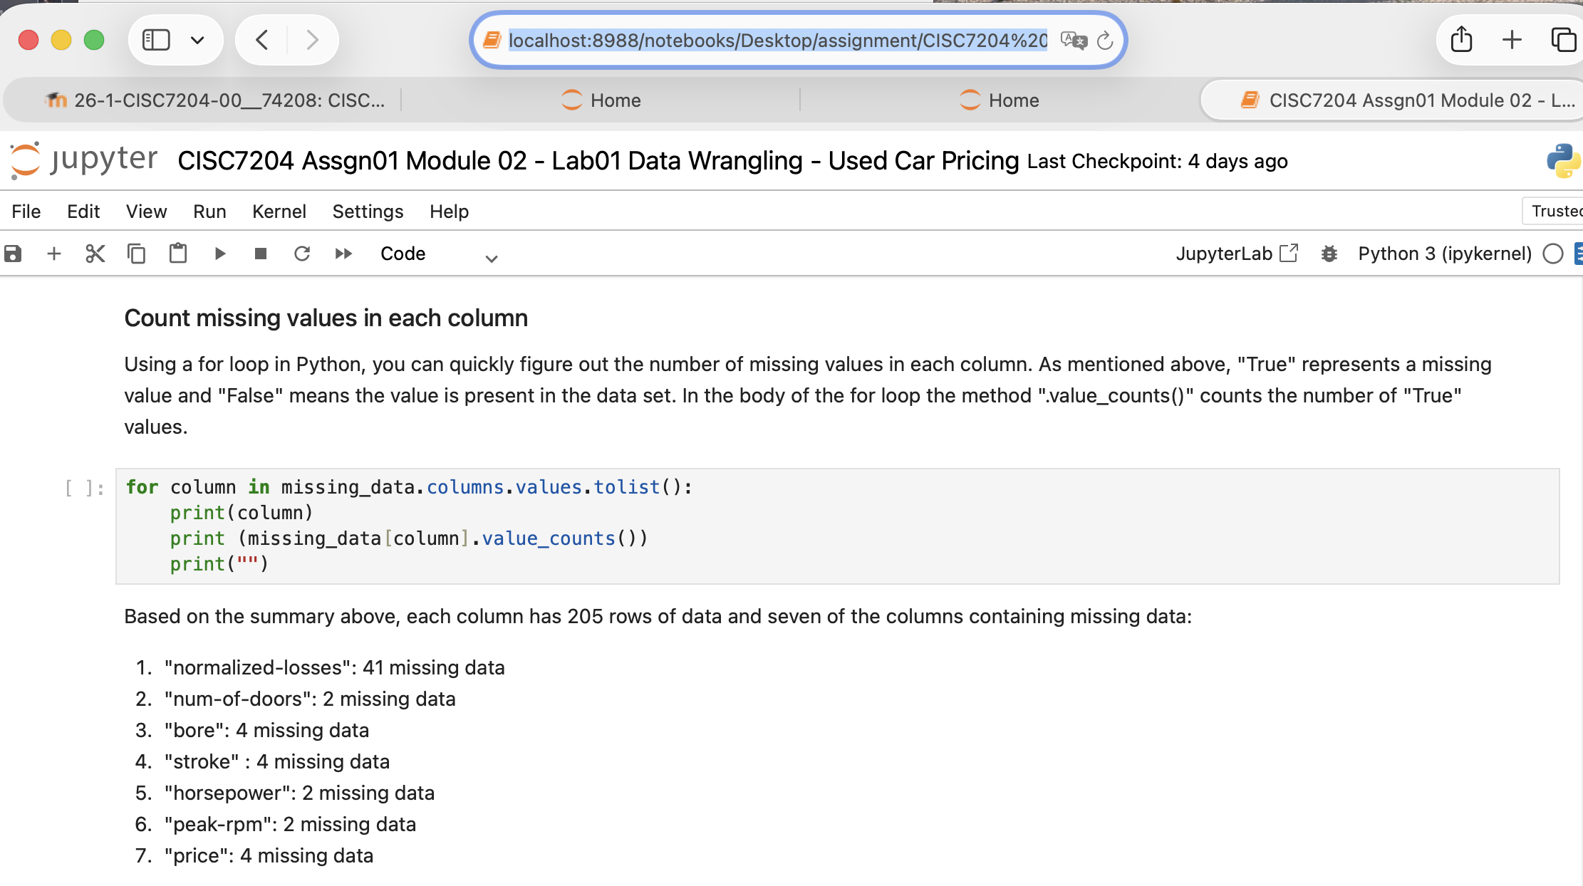
Screenshot file: 09_Count_missing_values_per_column.png
A short loop sums the True values of the mask for each column and prints how many entries are missing per attribute, which decides how each column is treated.

Lab1_10. Section 2 Deciding how to replace the missing data
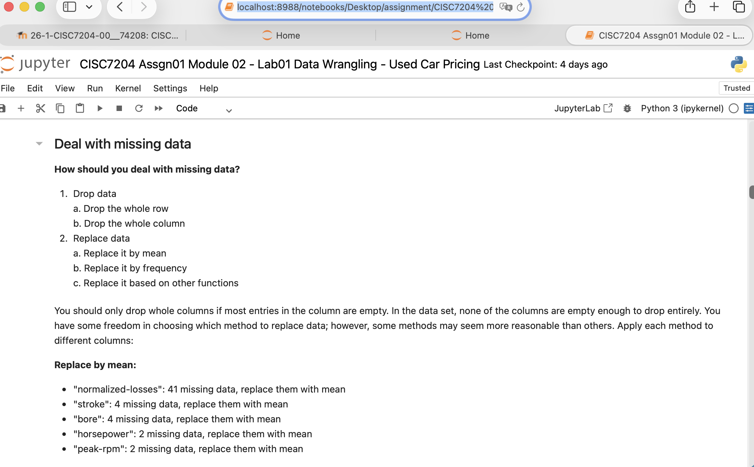
Screenshot file: 10_Deal_with_missing_data.png
The section explains that no column is empty enough to be dropped, so missing values are replaced, with the mean for continuous attributes and the most frequent value for categorical ones.

Lab1_11. Section 2 Calculating the mean of normalized-losses
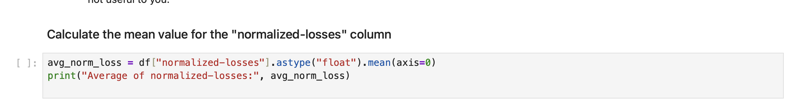
Screenshot file: 11_Calculate_mean_normalized_losses.png
The mean of the normalized-losses column is computed and printed (about 122), the value that will fill the missing entries.

Lab1_12. Section 2 Filling normalized-losses with its mean
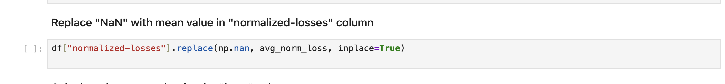
Screenshot file: 12_Replace_NaN_with_mean_normalized_losses.png
replace is applied to the column so every NaN becomes the mean value, the pattern used for the remaining continuous attributes.

Lab1_13. Section 2 Calculating the mean of the bore column
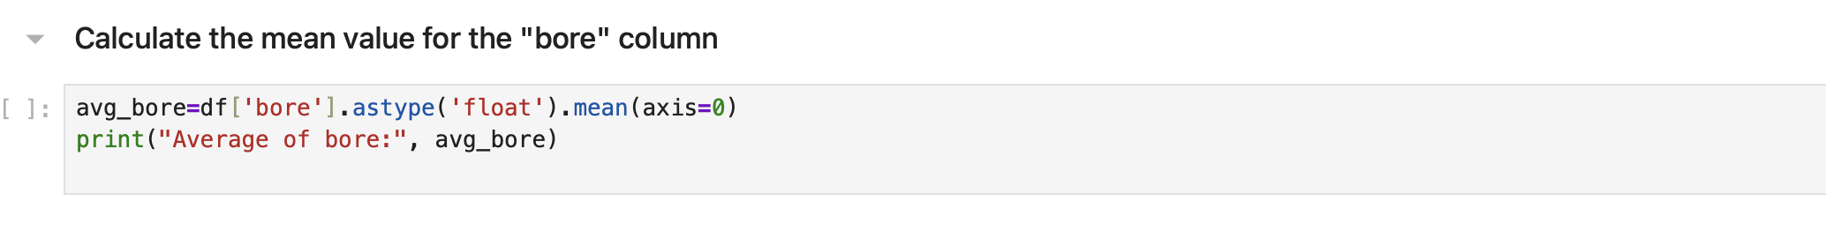
Screenshot file: 13_Calculate_mean_bore.png
avg_bore = df['bore'].astype('float').mean(axis=0) returns about 3.33 and prints the label 'Average of bore'.

Lab1_14. Section 2 Filling the bore column with its mean
Screenshot file: 14_Replace_NaN_with_mean_bore.png
The same replacement is applied to bore so the column holds no missing values before the type conversion.

Lab1_15. Question 1 Replacing the missing stroke values with the mean
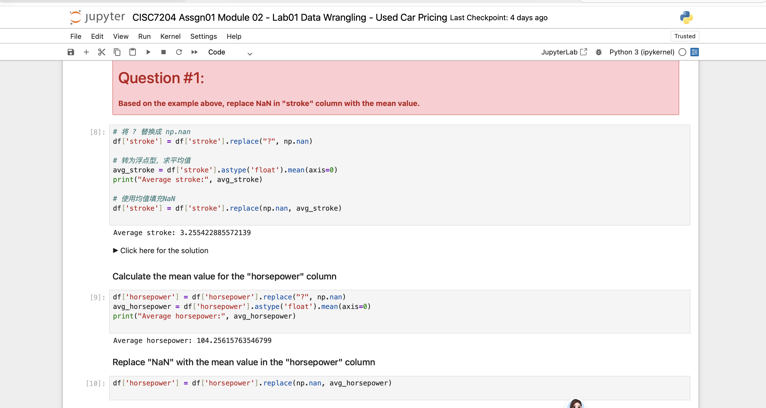
Screenshot file: Question1.1.png
The answer converts the stroke column to float, prints its mean (about 3.255) and fills the missing entries with that value.

Lab1_16. Question 1 continued: the mean of the horsepower column
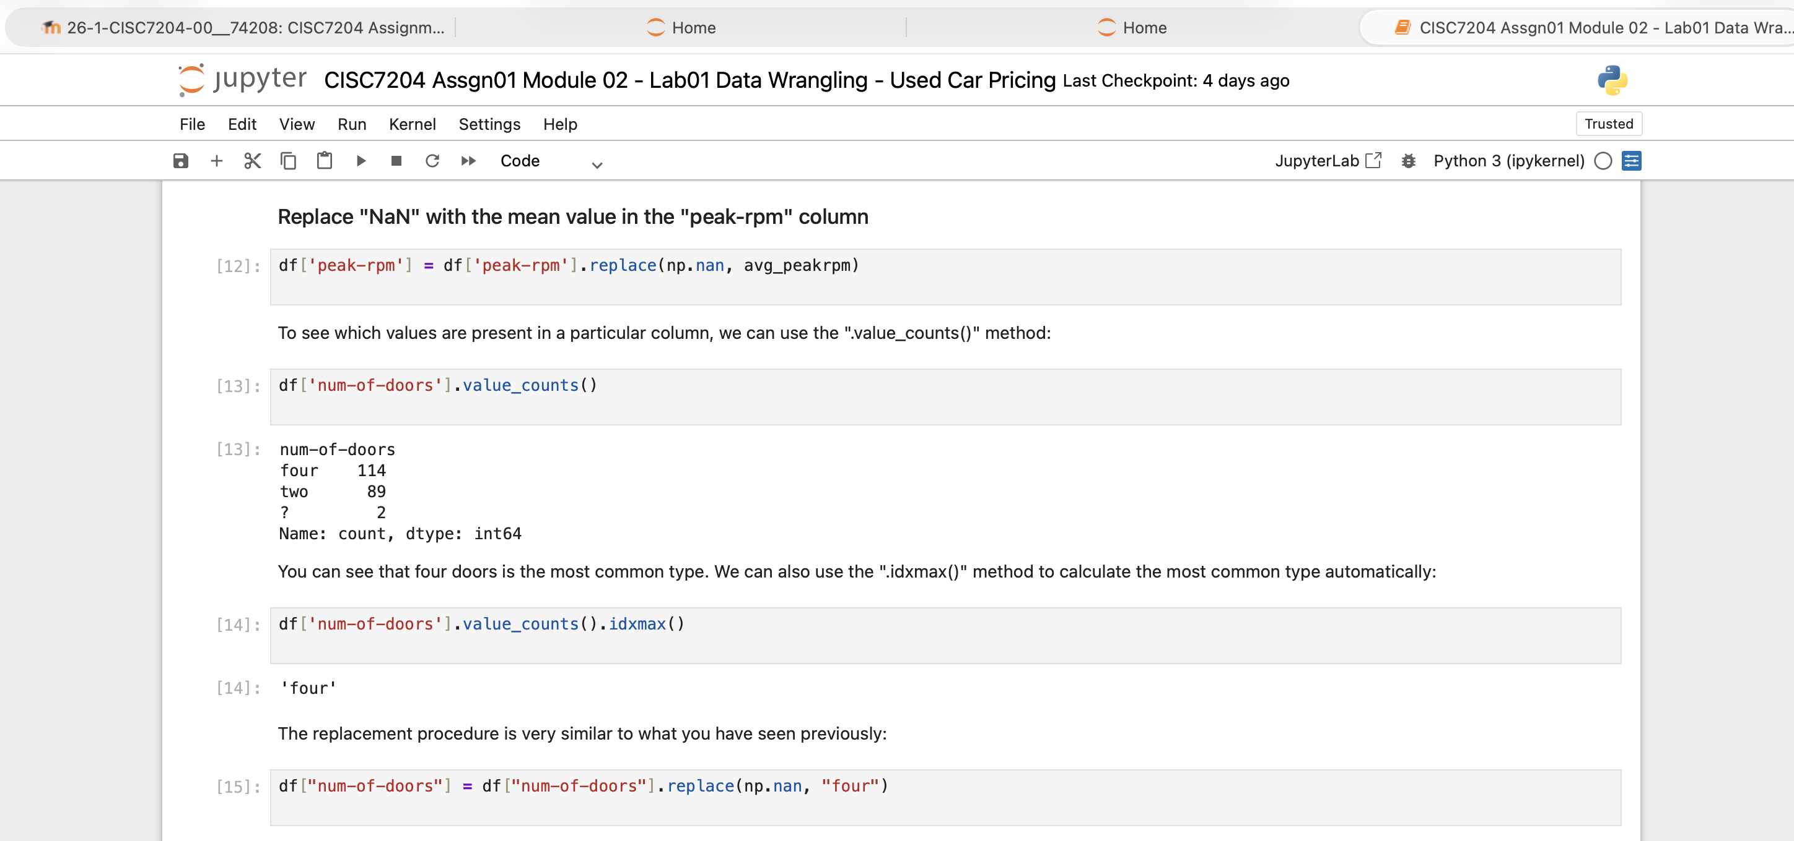
Screenshot file: Question1.2.png
The same pattern is applied to horsepower; the mean of about 104.26 is printed as the label for the following replacement.

Lab1_17. Section 2 Data types before the correction
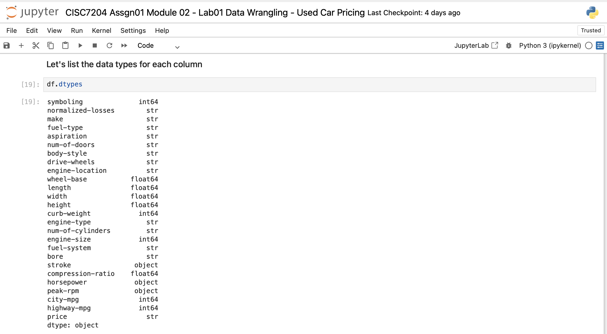
Screenshot file: 15_df_dtypes.png
df.dtypes shows that several numeric attributes such as bore, stroke, normalized-losses and price are still stored as objects, the issue that the next step fixes.

Lab1_18. Section 2 Converting the attributes to numeric
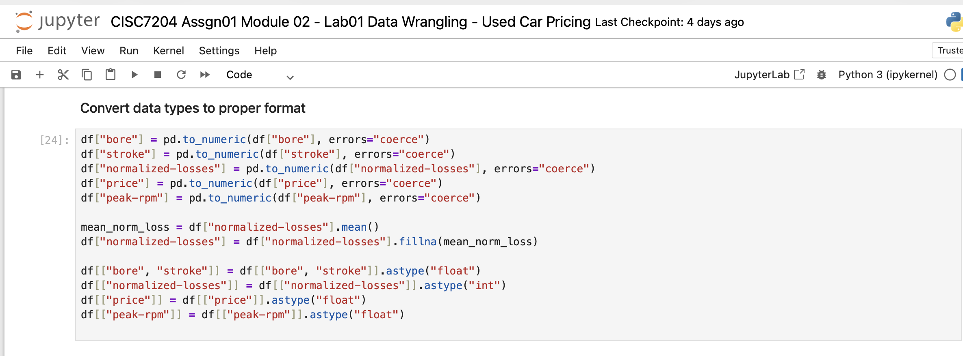
Screenshot file: 16_Convert_data_types.png
pd.to_numeric is applied to the four attributes with errors='coerce', so any remaining non numeric entry becomes NaN and the columns come out as float64.

Lab1_19. Section 2 Data types after the conversion
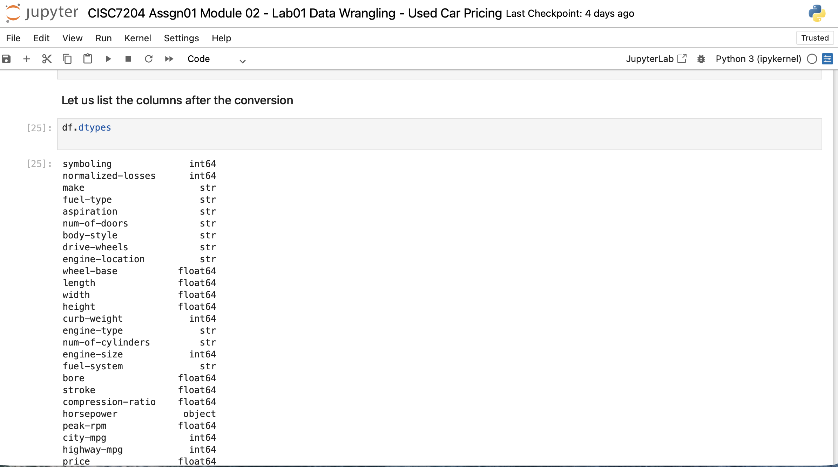
Screenshot file: 17_df_dtypes_after_conversion.png
The second df.dtypes confirms that bore, stroke, normalized-losses and price are now numeric.

Lab1_20. Section 3 Preparing the highway-mpg unit conversion
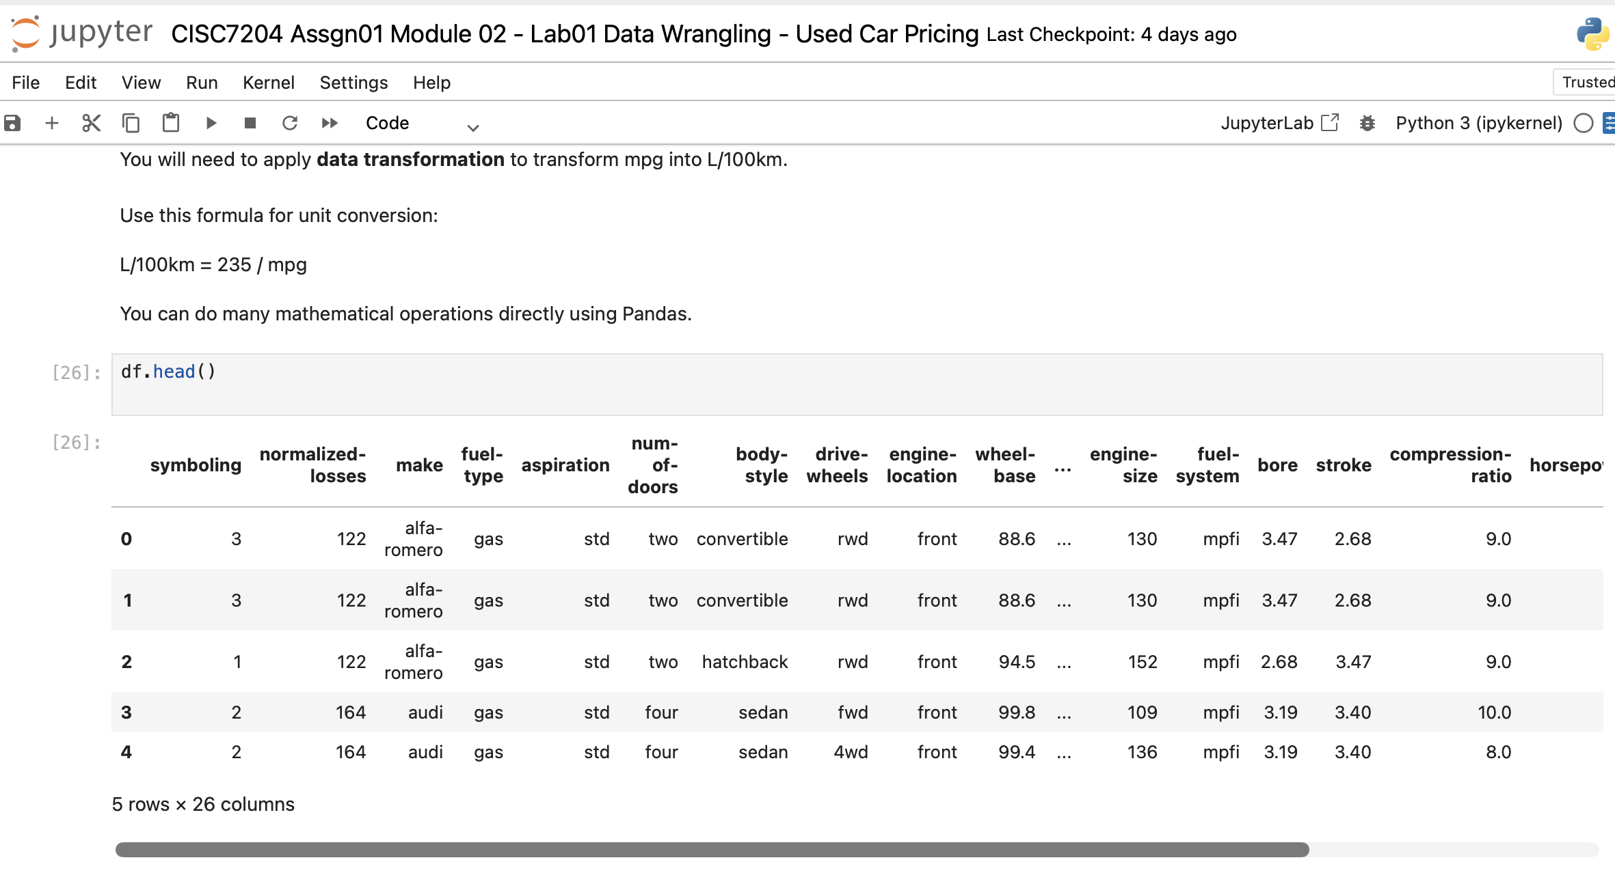
Screenshot file: 18_df_head_mpg_convert.png
The conversion formula L/100km = 235 / mpg is introduced and the first rows of the dataframe are shown before the new column is created.

Lab1_21. Question 1 continued: the dataframe after the replacements
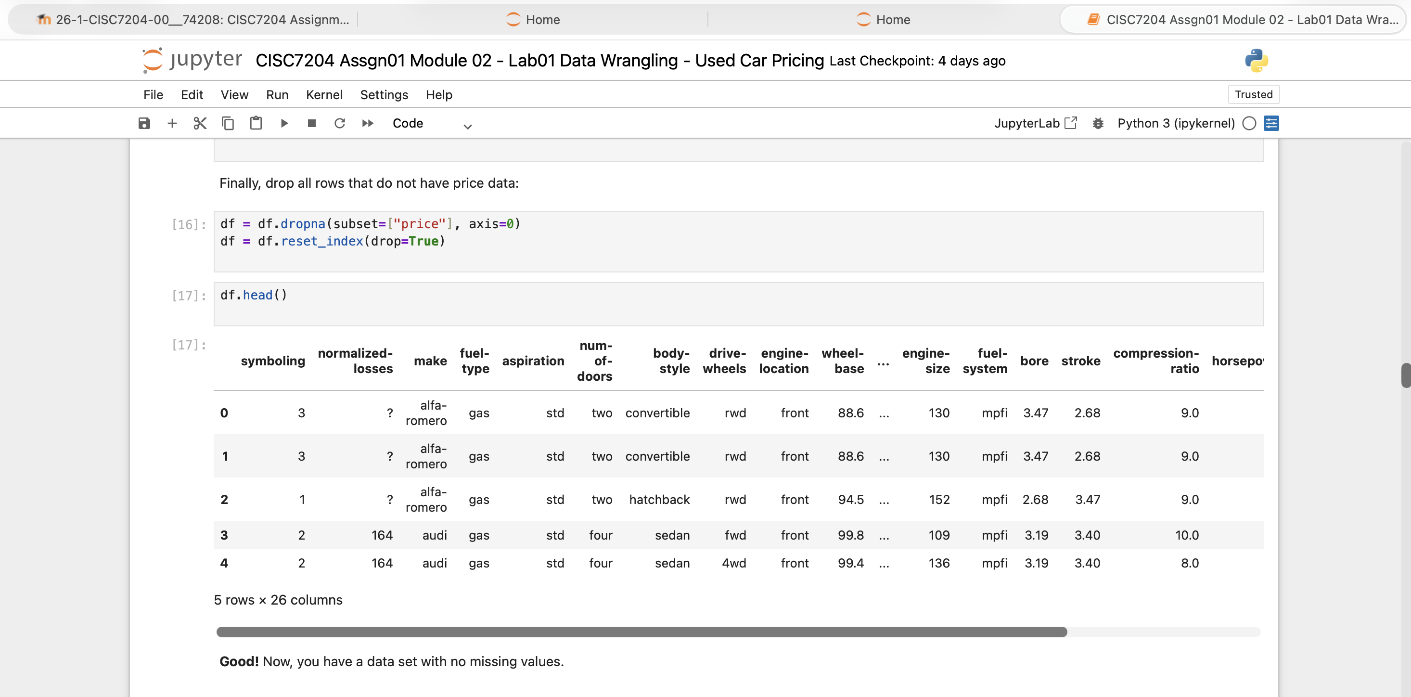
Screenshot file: Question1.3.png
The head of the dataframe is shown again so the filled columns can be checked against the values printed above.

Lab1_22. Section 3 Normalising the length column
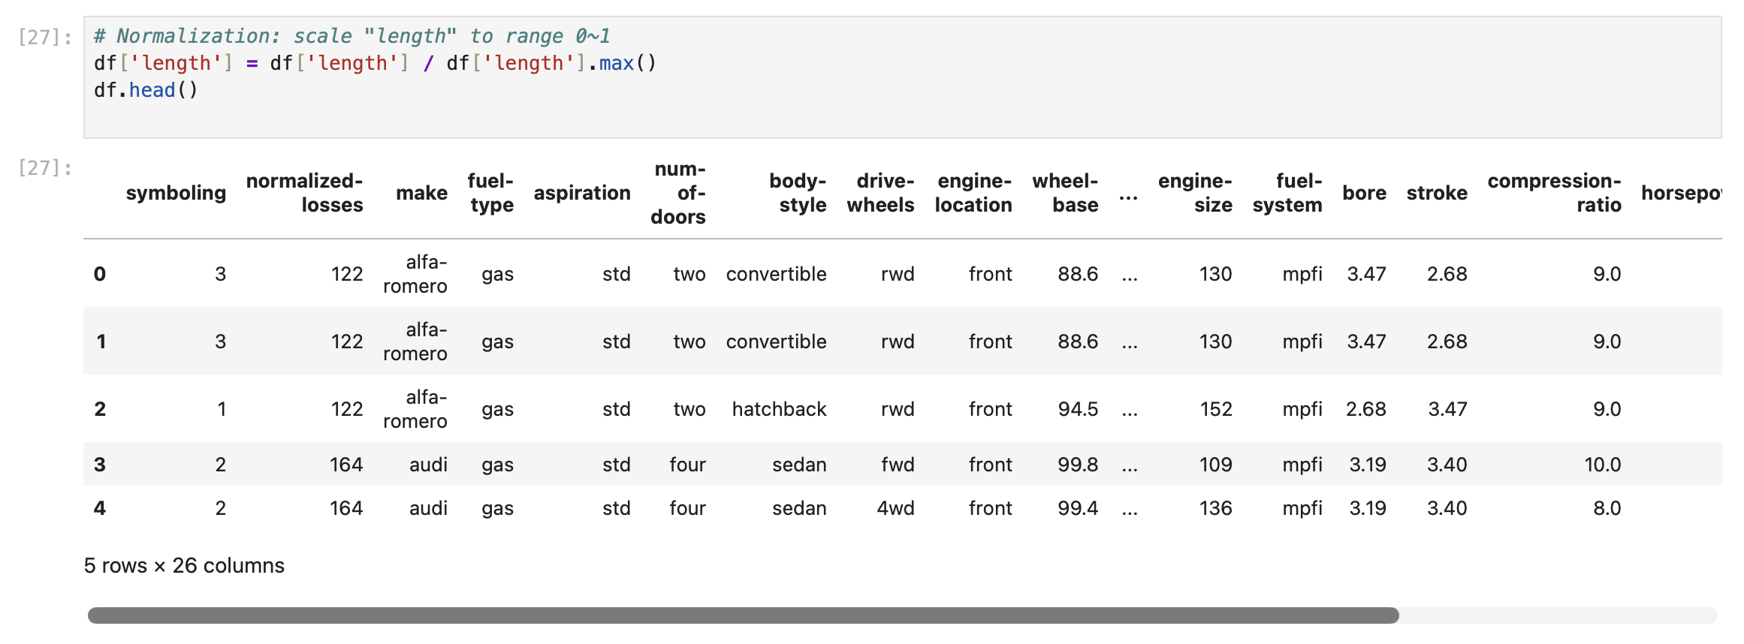
Screenshot file: 19_normalize_length.png
df['length'] divided by its maximum rescales the column into the range 0 to 1, the example that the following questions follow.

Lab1_23. Question 2 Converting highway-mpg to litres per 100 km
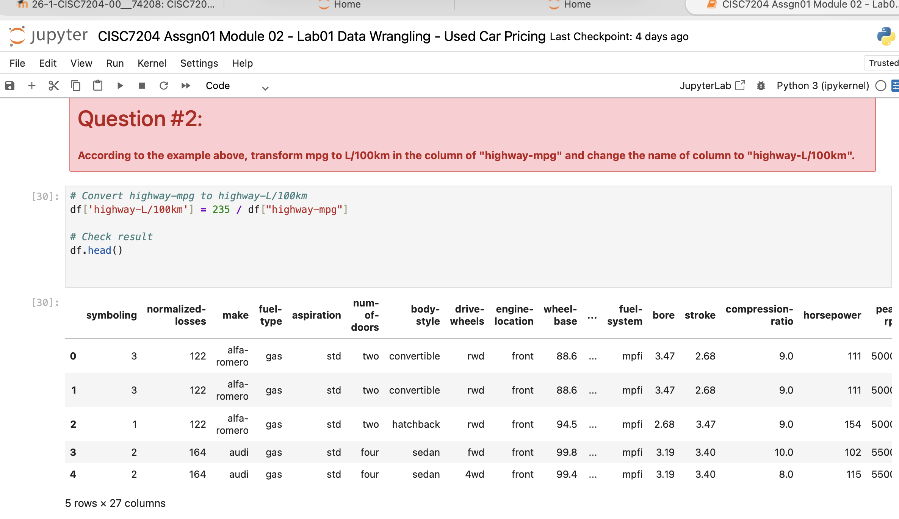
Screenshot file: Question2.png
df['highway-L/100km'] = 235 / df['highway-mpg'] adds the converted attribute and the head of the frame shows it next to the original column.

Lab1_24. Section 3 Why normalisation is used
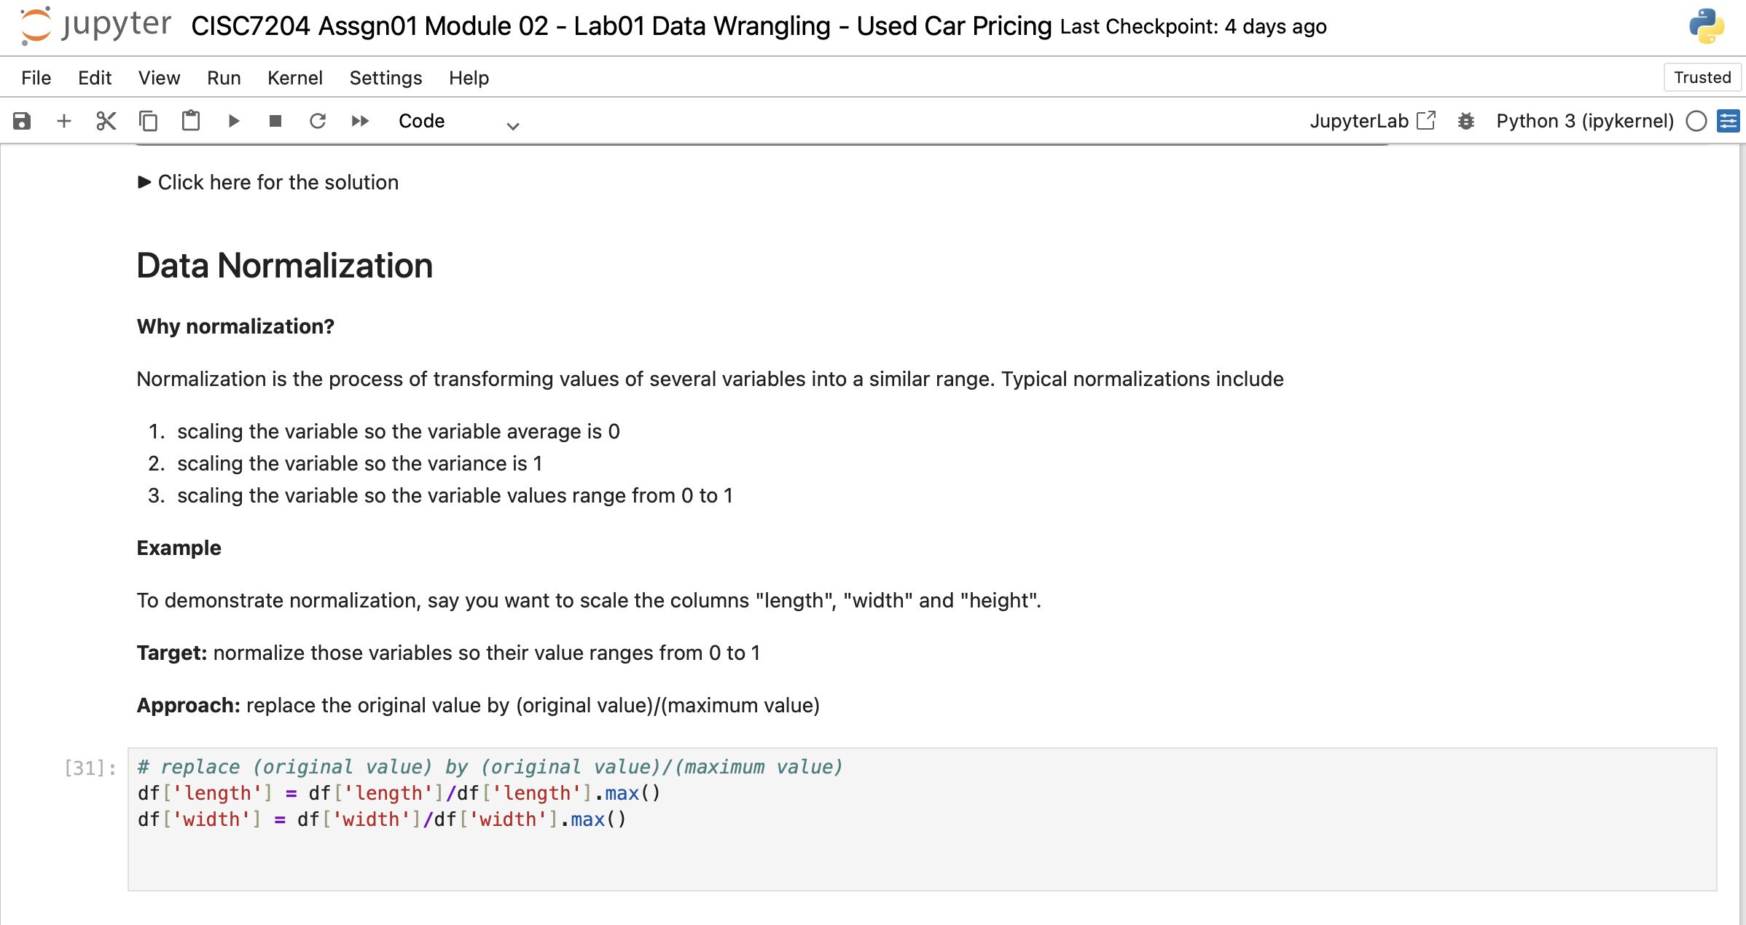
Screenshot file: 21_data_normalization_intro.png
The section explains that normalisation brings variables measured in different units into a comparable range so that none of them dominates a model because of its scale.

Lab1_25. Question 3 Normalising the height column
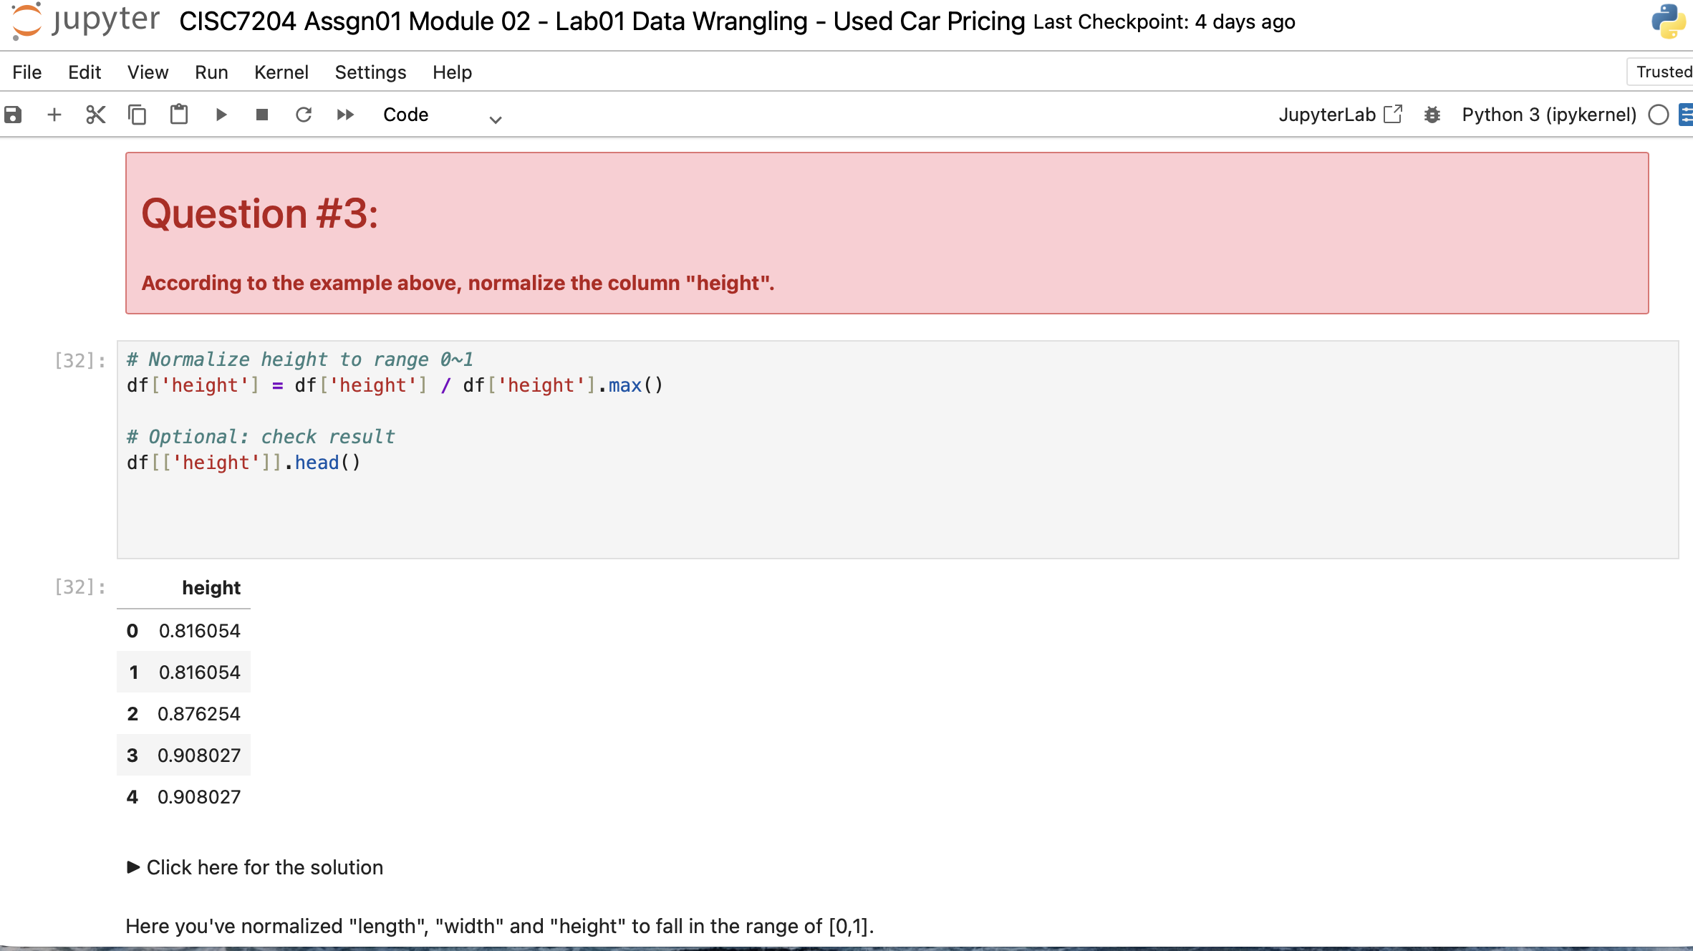
Screenshot file: Question3.png
df['height'] divided by its maximum puts the attribute into the 0 to 1 range, following the normalisation example from the section above.

Lab1_26. Section 4 First look at the horsepower distribution
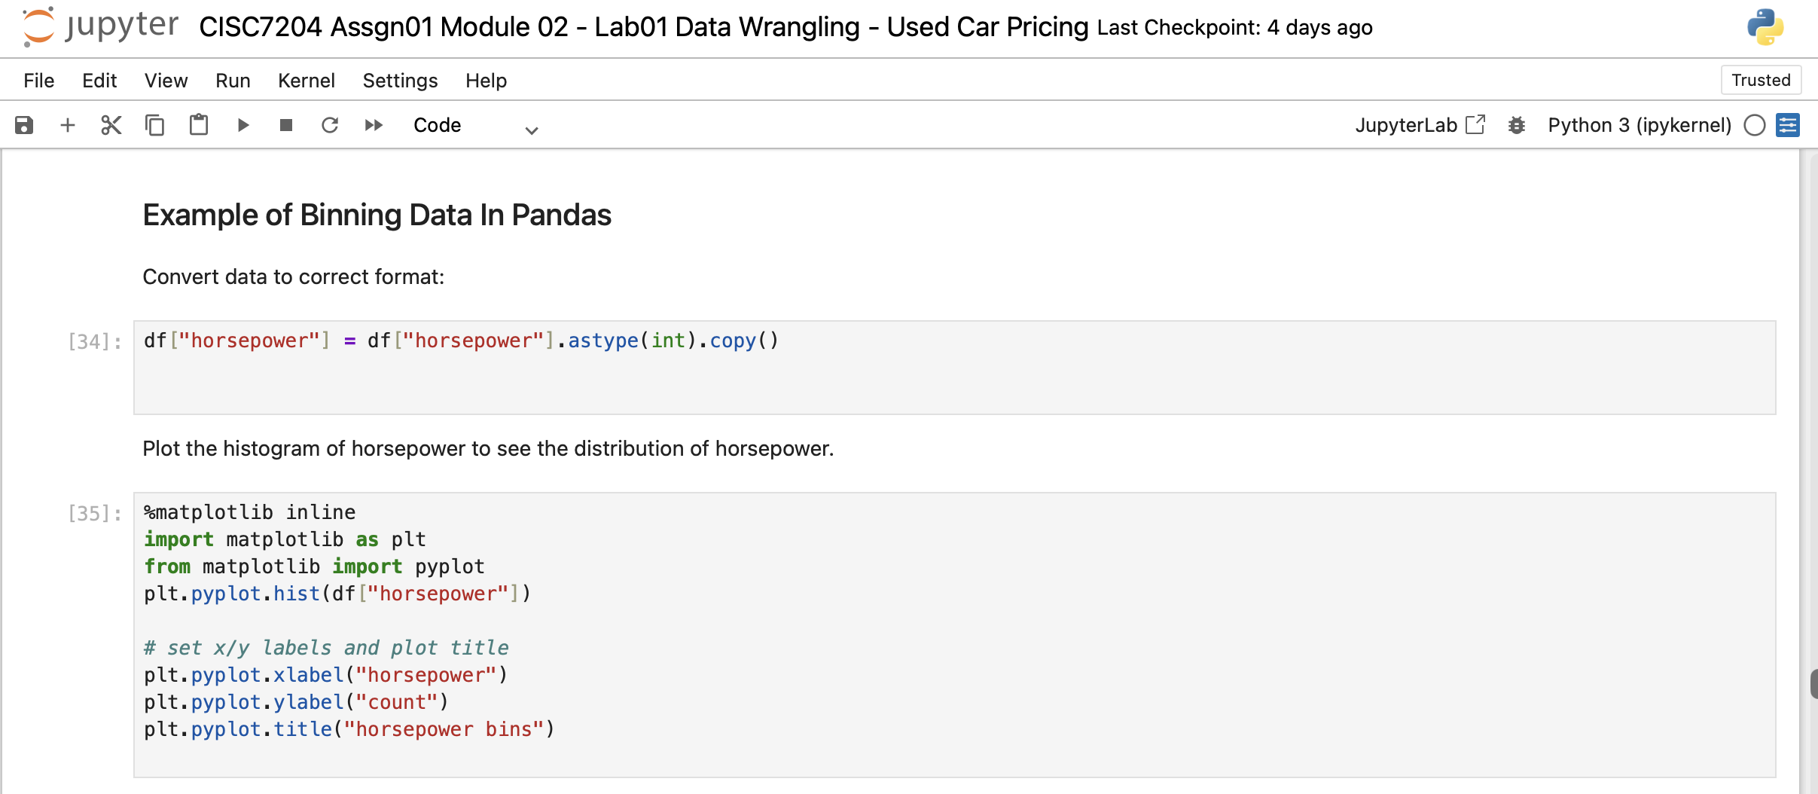
Screenshot file: 23_binning_horsepower_example.png
The histogram of the horsepower column introduces binning by showing how the values are distributed before they are grouped.

Lab1_27. Section 4 Binning horsepower into three groups
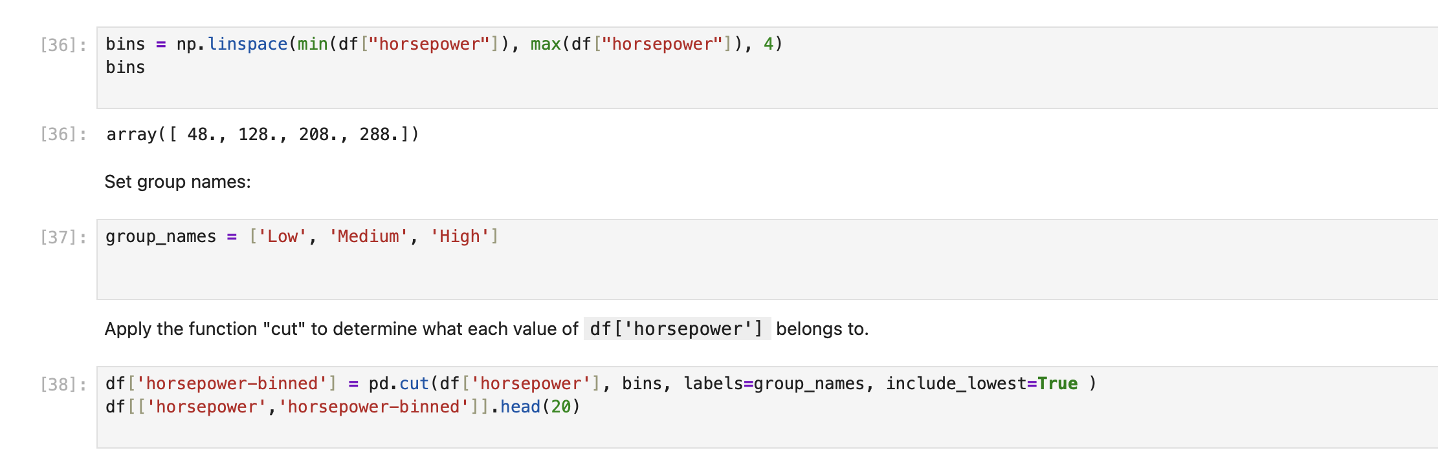
Screenshot file: 24_binning_cut_horsepower.png
pd.cut splits horsepower into the groups Low, Medium and High and stores the result in the new horsepower-binned column.

Lab1_28. Section 4 Bar chart of the binned horsepower counts
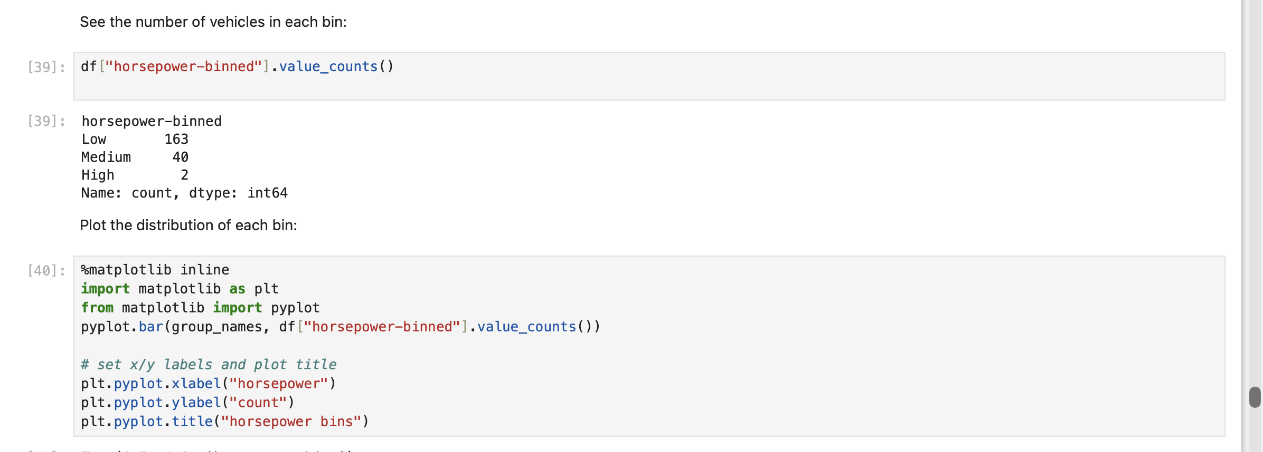
Screenshot file: 25_binning_valuecount_barplot.png
The bar chart counts the cars in each of the three bins so the effect of the cut is visible.

Lab1_29. Section 4 Histogram of horsepower with three bins
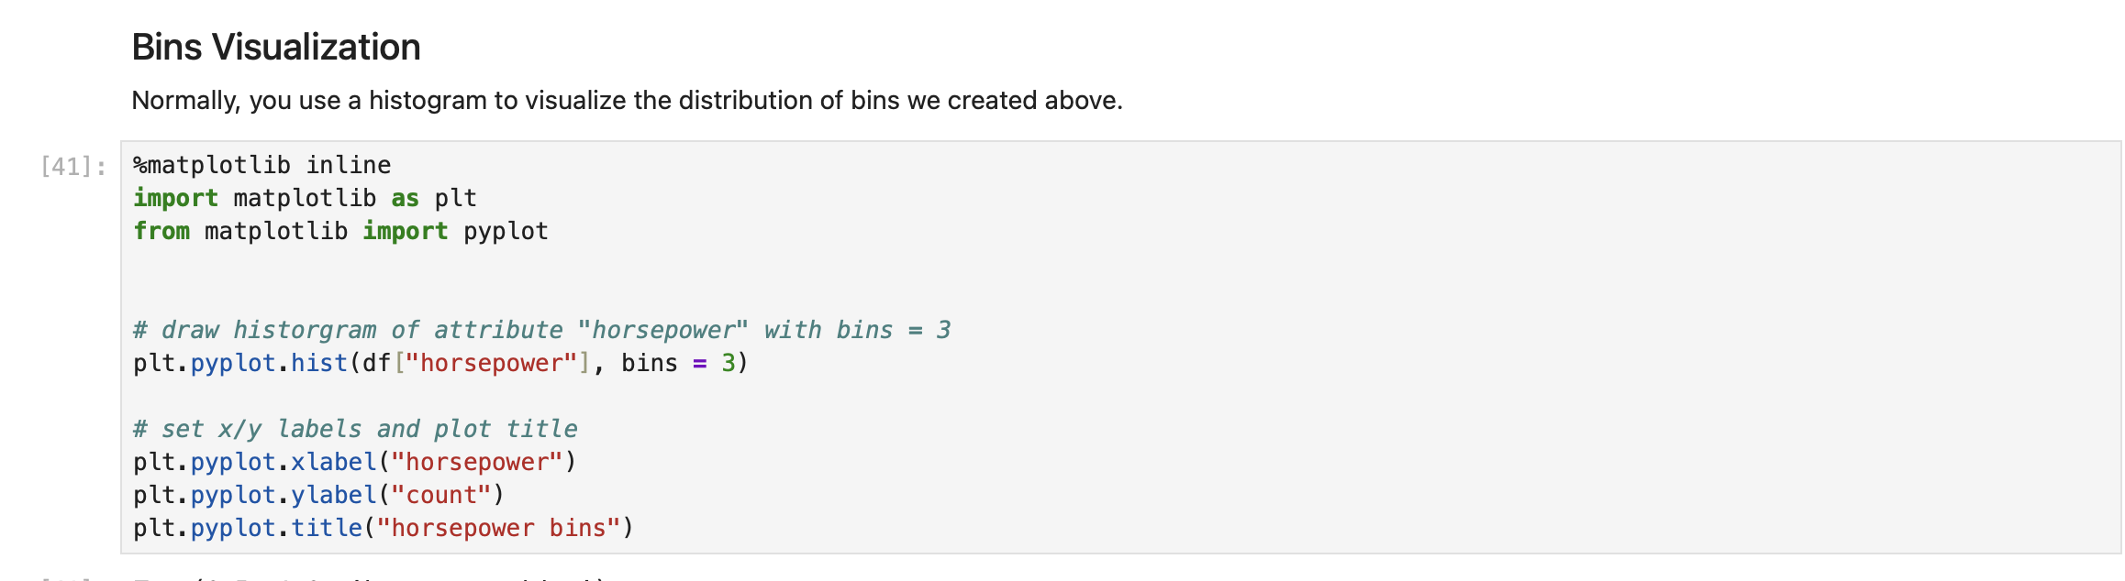
Screenshot file: 26_bins_hist_visualization.png
The same division is drawn as a histogram with three bins, which is the graphical counterpart of the cut applied above.

Lab1_30. Section 5 What an indicator variable is
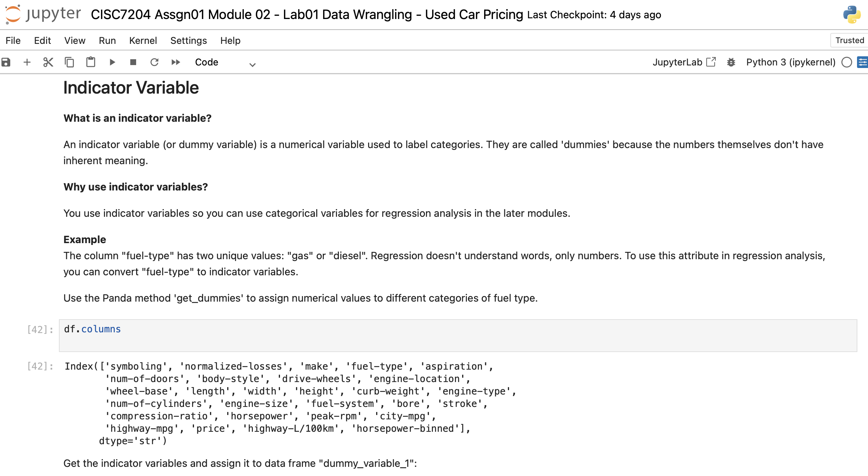
Screenshot file: 27_indicator_variable_dummy_intro.png
The section explains that indicator or dummy variables encode categories as 0 and 1 so that categorical attributes can be used by a regression model.

Lab1_31. Question 4 Creating the indicator variable for aspiration
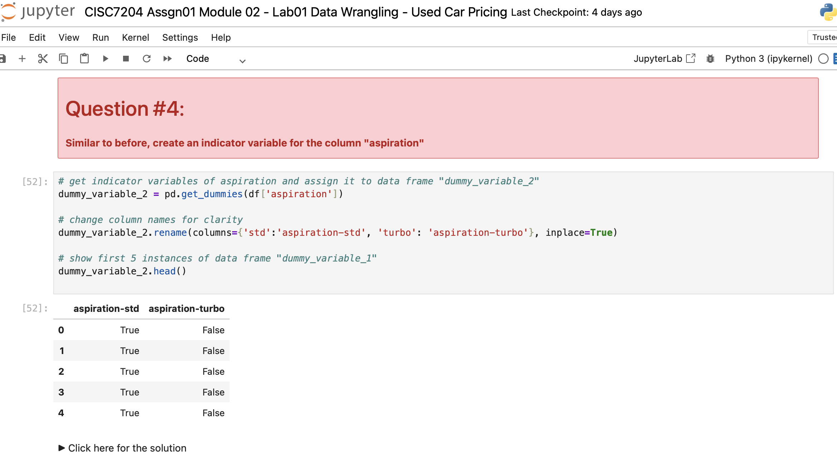
Screenshot file: Question4.png
The aspiration column is turned into indicator variables with get_dummies, so the two categories become 0 and 1.

Lab1_32. Section 5 Renaming the fuel-type indicator columns
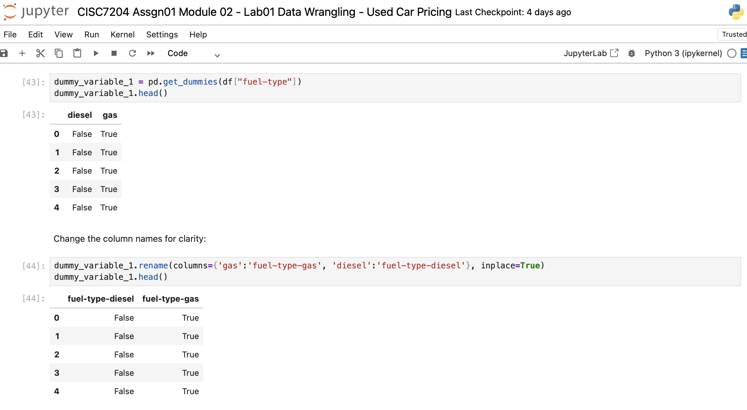
Screenshot file: `28_dummy_fuel_type_rename_col.png`.png
The dummy columns produced from fuel-type are renamed to diesel and gas so they can be read without referring back to the original category names.

Lab1_33. Question 5 Merging the indicator variable and dropping aspiration
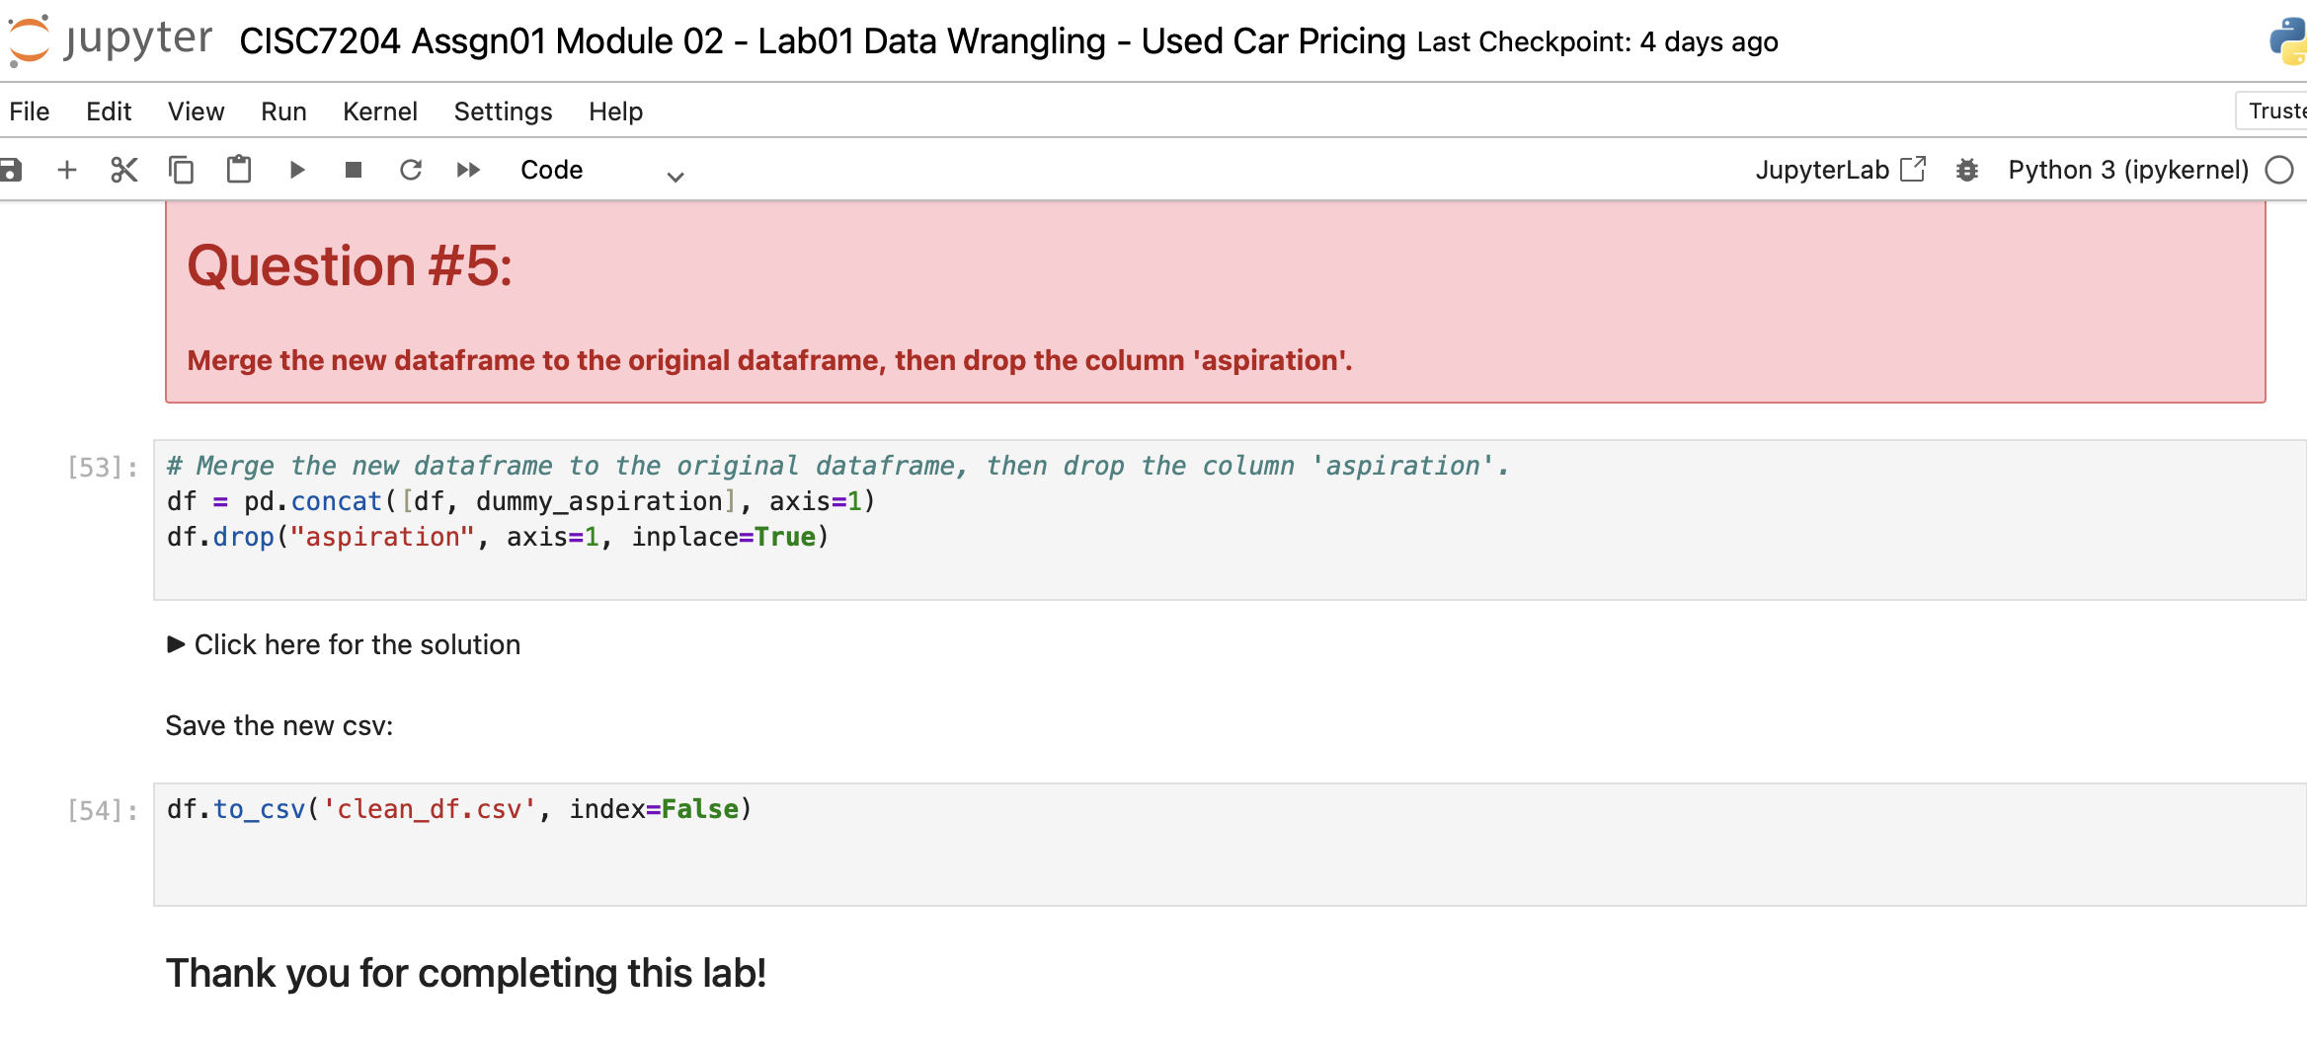
Screenshot file: Question5.png
pd.concat joins the new columns to the dataframe and the original aspiration column is removed, which is the drop that keeps the frame tidy.

Lab1_34. Section 5 Final check of the merged dataframe
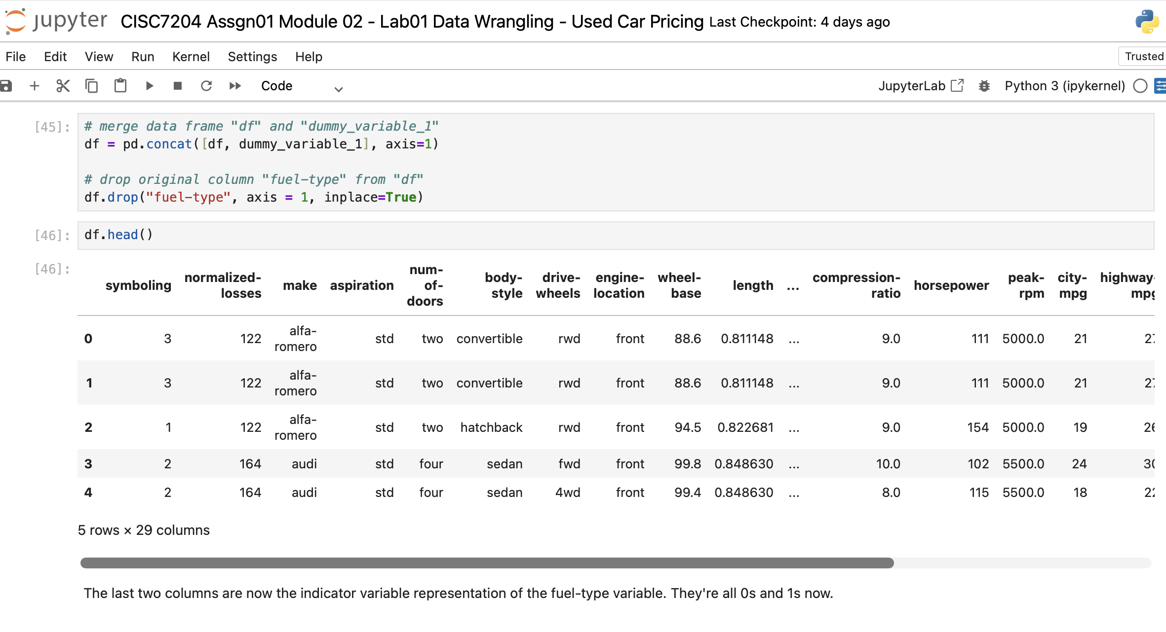
Screenshot file: `29_concat_dummy_and_drop_original_column.png
df.head() shows the dataframe after the merge and the drop, with the indicator columns in place and the original categorical column gone.

